Advanced workshop in chemistry:

Linear molecules spectroscopy

Lea Bromberg, Yakir Levi Sagzan

Table of Contents

Spectrum of : 2

Rotational constants: 2

Moment of inertia: 3

Bond length: 3

Spring constant: 5

Summary table: 6

Comparison to literature values: 7

7

7

8

Spectrums of , and : 9

Rotational constants: 10

Moment of inertia: 10

Bond length: 11

Force constant: 13

Summary table: 15

17

To determine the rotational constant and its anharmonic correction, they were extracted directly from the fitting to equation.

We will show all the calculations for molecules, the same calculations were also performed on:

# Spectrum of :

Fitting equation:

We can use a second fitting equation:

From here we can understand that:

## Rotational constants:

## Moment of inertia:

On the other hand, the moment of inertia in terms of the rotational constant equals:

From these 2 equations we can calculate the bond length.

## Bond length:

The same calculations were done for the other modes of the molecule.

## Spring constant:

Since the third mode yielded a closer equilibrium bond length to the literature value, the force constant that is responsible for bending was calculated by using that value.

The same calculations were done for the .

## Summary table:

|  |  |  |  |
| --- | --- | --- | --- |
|  |  | |  |
|  |  |  |  |
|  |  |  |  |
|  |  |  |  |
|  |  |  |  |
|  |  |  |  |
|  |  |  |  |
|  |  |  |  |
|  |  |  |  |
|  |  |  |  |
|  |  |  |  |

## Comparison to literature values:

|  |  |  |  |
| --- | --- | --- | --- |
|  |  |  |  |
|  |  |  |  |
|  |  |  |  |
|  |  |  |  |
|  |  |  |  |
|  |  |  |  |
|  |  |  |  |
|  |  |  |  |
|  |  |  |  |
|  |  |  |  |

|  |  |  |  |
| --- | --- | --- | --- |
|  |  |  |  |
|  |  |  |  |
|  |  |  |  |
|  |  |  |  |
|  |  |  |  |
|  |  |  |  |
|  |  |  |  |
|  |  |  |  |
|  |  |  |  |
|  |  |  |  |

|  |  |  |  |
| --- | --- | --- | --- |
|  |  |  |  |
|  |  |  |  |
|  |  |  |  |
|  |  |  |  |
|  |  |  |  |
|  |  |  |  |
|  |  |  |  |
|  |  |  |  |
|  |  |  |  |
|  |  |  |  |

# Spectrums of , and :

Fitting equation:

## Rotational constants:

|  |  |  |  |
| --- | --- | --- | --- |
|  |  |  |  |
|  |  |  |  |
|  |  |  |  |
|  |  |  |  |
|  |  |  |  |

## Moment of inertia:

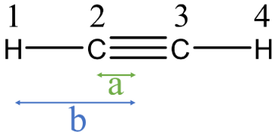

Where a – is half of the bond distance   
and b – is the distance of the bond with half of the bond distance

On the other hand, the moment of inertia in terms of the rotational constant equals:

For ,under isotopic exchange, distances remain the same, and the only difference is in the mass, instead of . Thus:

## Bond length:

To get the structure of the molecule, we’ll solve the following system of equations:

## Force constant:

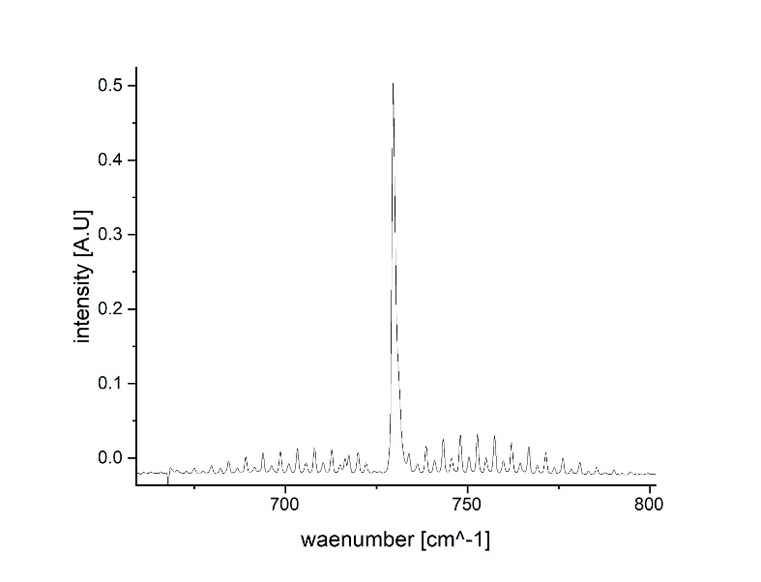Although not all the modes are IR active, we could still use the observed combination bands and extrapolate the fundamentals we needed.

Using the following relationships of the fundamental frequencies, we are now able to calculate the relevant force constants of acetylene:

We can use both and relationships to calculate the bending force constant.

Using expression:

Using expression:

Using the relationship for :

We can determine this force constant by using the relationships of either the combination or the product . We’ll do both.

Using the former:

and the latter:

## Summary table:

Rotational analysis of the combination band of both as well as including their relative errors.

Fundamental frequencies of both and isotopologues including their relative error.

|  |  |  |  |  |  |  |  |  |  |
| --- | --- | --- | --- | --- | --- | --- | --- | --- | --- |
|  |  |  |  |  |  |  |  |  |  |
|  |  |  |  |  |  |  |  |  |  |
|  |  |  |  |  |  |  |  |  |  |
|  |  |  |  |  |  |  |  |  |  |
|  |  |  |  |  |  |  |  |  |  |
|  |  |  |  |  |  |  |  |  |  |
|  |  |  |  |  |  |  |  |  |  |
|  |  |  |  |  |  |  |  |  |  |
|  |  |  |  |  |  |  |  |  |  |
|  |  |  |  |  |  |  |  |  |  |

stands for the force constant of stretch, for stretch force constant, for the bending force constant that was calculated via the relation and for the bending force constant that was calculated via the relation.

|  |  |  |  |
| --- | --- | --- | --- |
|  |  |  |  |
|  |  |  |  |
|  |  |  |  |
|  |  |  |  |
|  |  |  |  |
|  |  |  |  |
|  |  |  |  |
|  |  |  |  |